Triston Luzanta

ECE-2523

Dr.MetCalf

Project 4

1. 



1. 





|  |
| --- |
| Data |
| 0 |
| 1 |
| 2 |
| 3 |
| 4 |
| 5 |
| 6 |
| 7 |
| 8 |
| 9 |
| 10 |

Mean for both F and B:

Solution:

$\frac{0 + 1 + 2 + 3 + 4 + 5 + 6 + 7 + 8 + 9 + 10 }{11}$ = **5**

1. Variance for both F and B

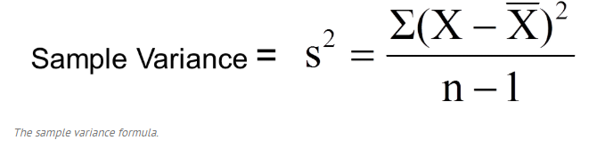

|  |  |  |
| --- | --- | --- |
| X |  | (2 |
| 0 | 5 | 25 |
| 1 | 5 | 16 |
| 2 | 5 | 9 |
| 3 | 5 | 4 |
| 4 | 5 | 1 |
| 5 | 5 | 0 |
| 6 | 5 | 1 |
| 7 | 5 | 4 |
| 8 | 5 | 9 |
| 9 | 5 | 16 |
| 10 | 5 | 25 |

Where X = data, $\overline{X}$ = mean. Plugging the values in we get S2 = = 27.5.

S = = **5.24**

1. The means for the fair toss generated compared to the true mean was a little lower. The variance for the fair toss generated was a lot lower than the true variance.
2. The mean for the bias toss generated compared to the true mean was a little higher than the fair toss generated but less than the true mean. The bias toss variance was a little higher than the true variance.

Part 2.



Appendix:

